You are hereby cordially invited to participate in the

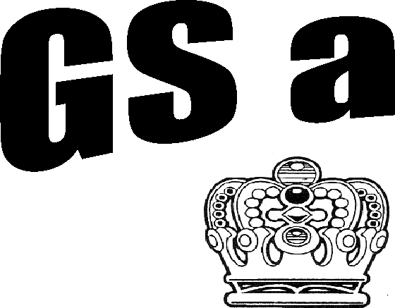

35th Annual Kings and Queens Couples Golf Tournament

(Players must be 18 years old)
at the

Murray Country Club in Murray, Kentucky Saturday and Sunday, June 23 and 24, 2018

Thursday & Friday, June 21 and June 22
Practice round of golf. Thursday after 2:00pm - All Day Friday. Tee times required. Additional $16.00 Cart Fee, per person, for practice round. Call (270) 753-9430 for tee times.
Saturday, June 23
First round of couples’ golf starts at 8:00am or 1:30pm.
Groups of three couples will start at each tee box. Each couple will play a two ball scramble.

Sunday, June 24
Second round of couples’ golf. All pairings will be based on your score from the First Round of play. Championship, 1st and 2nd Flights will all be in the afternoon. 3rd-6th (if applicable)
Championship Flight will all start on hole #1 in a staggered format. NO EXCEPTIONS.
Lunch will be provided after the morning round and before the afternoon round both days.
FLIGHT PRIZES TO BE ANNOUNCED

IMPORTANT
ENTRY: $150.00 per couple includes Green Fee for practice round of golf, mulligans both days, lunch both days.
First come - first serve basis. Only the first 132 pre-paid entries will be accepted. Deadline for refund, June 15.

IT IS ILLEGAL TO BRING PRIVATE ALCOHOLIC BEVERAGES ONTO THE PREMISES
The State of Kentucky Alcoholic Beverage Control License held by the Murray Country Club prohibits alcoholic beverages on the premises unless purchased from the license holder.

ENTRY FORM

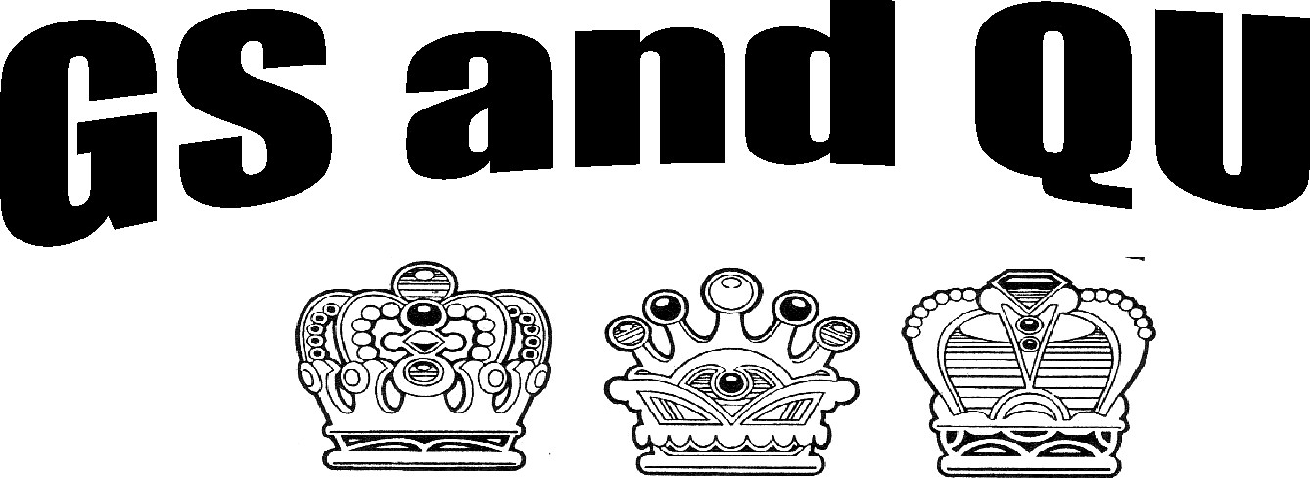

35th Annual Kings and Queens Couples Tournament

Saturday and Sunday, June 23 and 24, 2018

Murray Country Club KY

Please print clearly and complete form in full

Name:
Address:
City: State: Zip
Telephone: (*Please include area code)

Email: _____________________________________ (*For updates and Sunday pairings)

Preferred Starting Time: Sat. 8:00am Sat 1:30pm Check here if you are bringing your own cart
Check here to reserve a cart for Saturday and Sunday
Enclose check for $60.00. $ Only pre-paid cart reservations will be guaranteed.
ENTRY FEE OF $150.00 MUST ACCOMPANY APPLICATION. $
TOTAL $

I would like to play with:

ALL PAIRINGS BY TOURNAMENT COMMITTEE FINAL
Enclose a check for total amount payable to Murray Country Club K & Q and mail to:
Murray Country Club, P0 Box 310, Murray, Kentucky 42071

